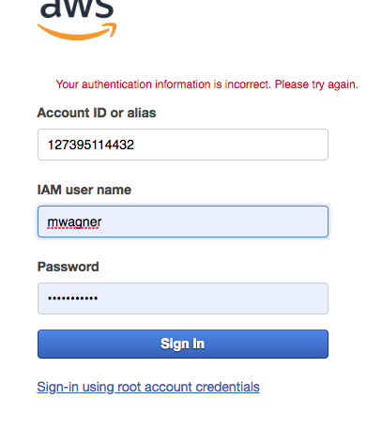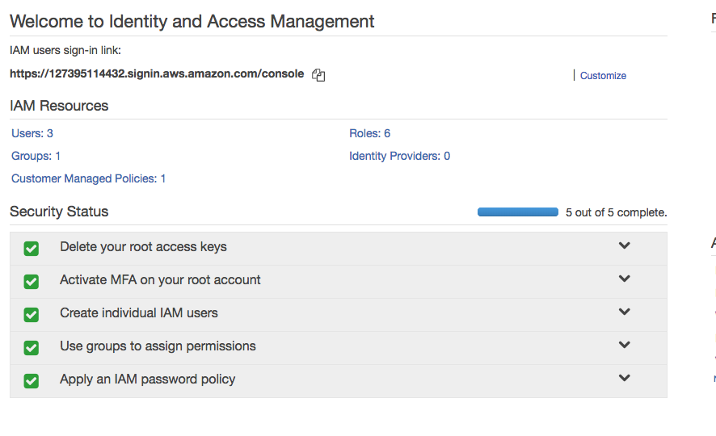SystemSub:Users:Terrapin:Desktop:UMUC:homeowrk 0and1:Screen Shot 2019-03-21 at 11.26.26 AM.png